

Sri Lanka Institute of Information Technology

**Web Services**

**Movie Booking System**

**Project Report**

Distributed System Assignment 02

Submitted by:

IT15000118 – (L.L.C.T. Alwis)

Submitted to:

………………………………

Dr. Dharshana Kasthurirathna

**1).Introduction**

Online Movie Center is an online web application which user can check available movies buy movie tickets online by paying either Dialog Easy Cash or Sampath Credit Card.

**2). High Level Architectural Diagram**

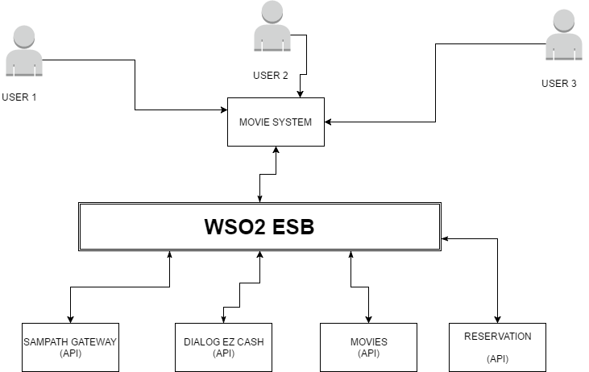

(Figure 2.1 – Architectural Diagram)

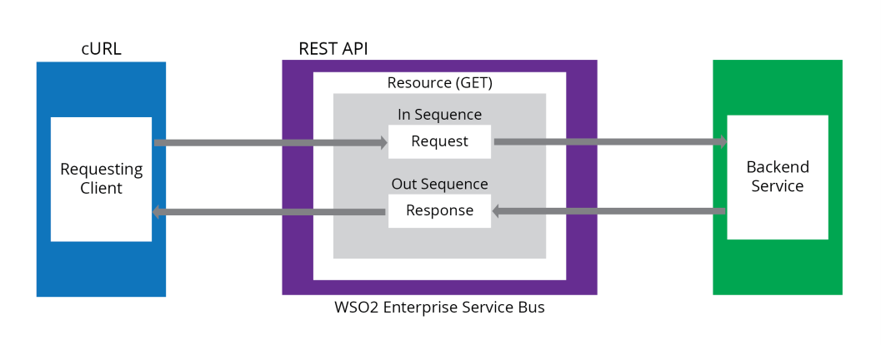

(Figure 2.1 – Architectural Diagram)

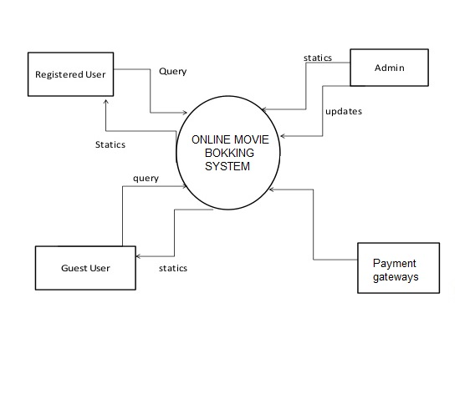

(Figure 2.2 – Level 0 DFD Diagram)

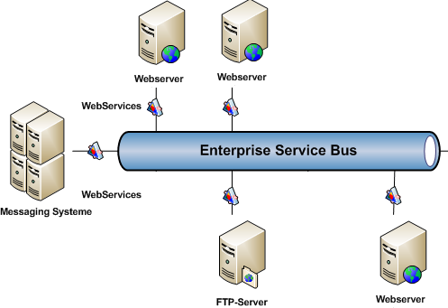

(Figure 2.3 – System Diagram)

**3). Flow Charts**

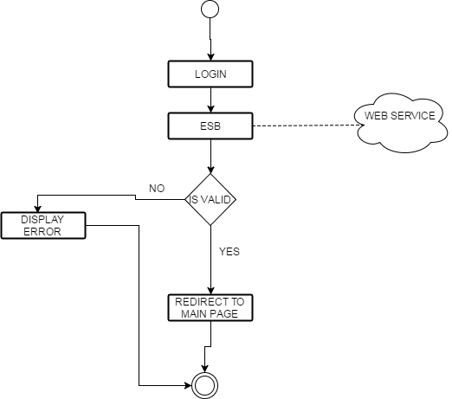

(Figure 3.1 – Login Flow Chart)

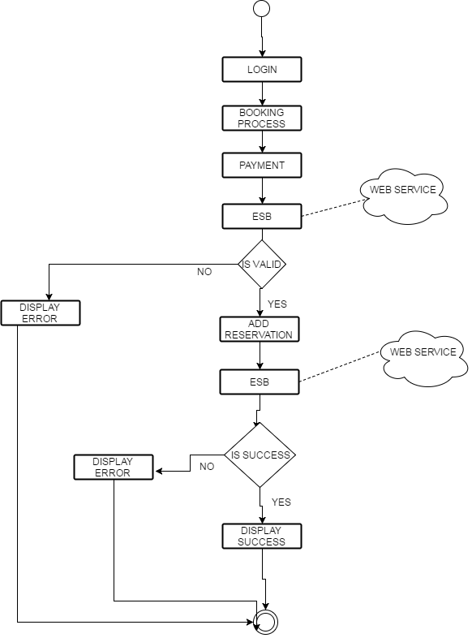

(Figure 3.2 – Main Flow Chart)

**4) Web Services**

1. **Reservation**

The reservation web service is used to add reservation details such as movie time, snack order, theater name, movie name, etc. This webservice is created using java Springboot the end points of the webservice is deployed in the WSO2 ESB.

1. **Dialog Easy Cash**

The dialog ez cash web service is used to add payment method where user pay for the service by using dialog ez cash. Mobile number, amount and pin will be entered to the database via a POST request. This webservice is created using java Springboot the end points of the webservice is deployed in the WSO2 ESB.

1. **Sampath Payment Gateway**

The Sampath payment gateway web service is used to add payment method where user pay for the service by his/her debit card. Customer number, CSV number, account number and other related attributes will be entered to the database via a POST request. This webservice is created using java Springboot the end points of the webservice is deployed in the WSO2 ESB.

1. **Authentication Web Service**

This webservice will be used to validate users. The system will send a request to ESB and the ESB will call the post method and get a Boolean output which contains the validity of the credentials provided by users. This webservice is created using java Springboot the end points of the webservice is deployed in the WSO2 ESB.

1. **Screenshots of the web client**

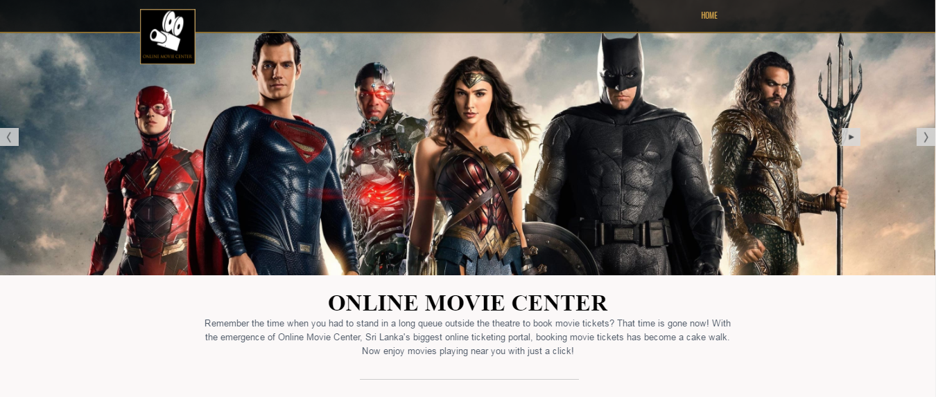

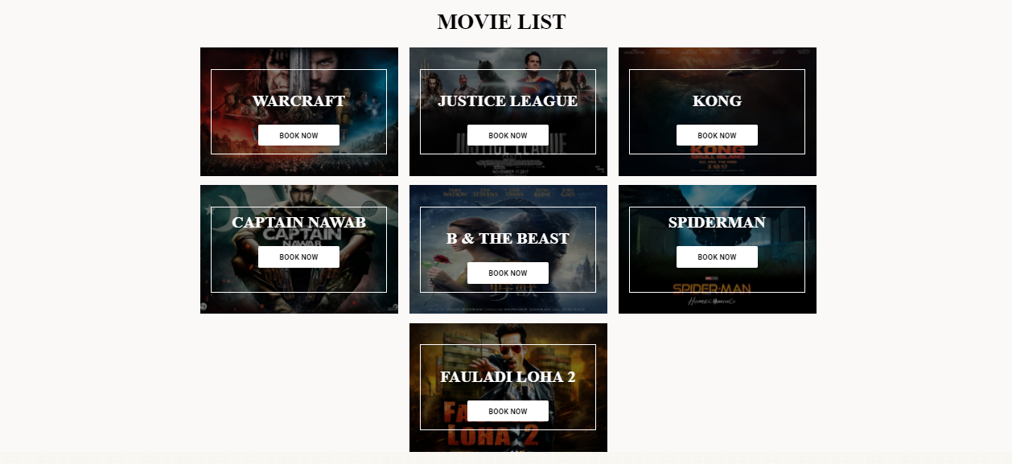

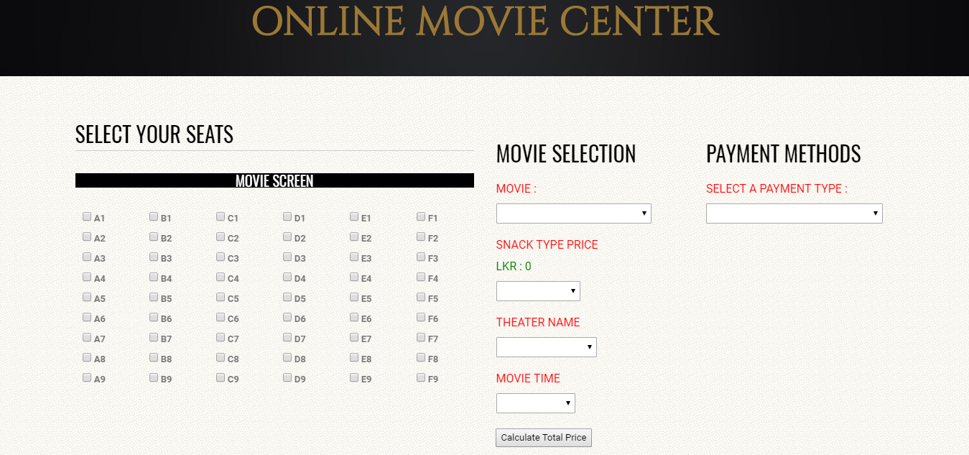

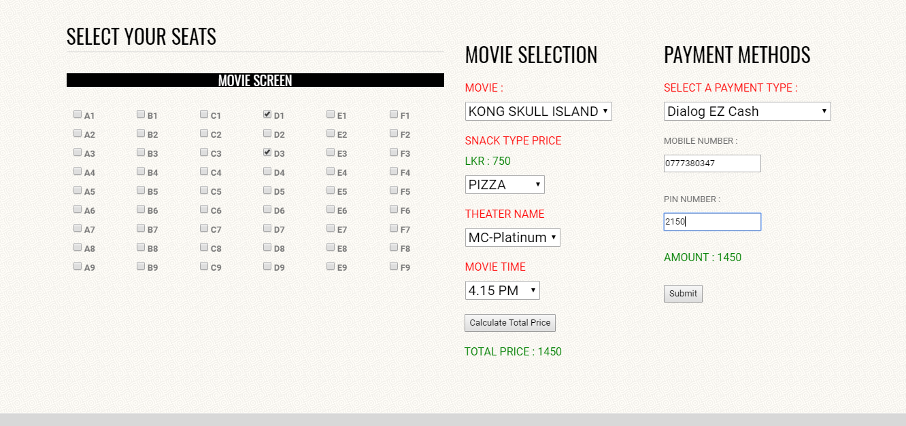

**6) Reference**

[1]"Stack Overflow", Stackoverflow.com, 2017. [Online]. Available: <http://stackoverflow.com>.

[2]"YouTube", Youtube.com, 2017. [Online]. Available: https://www.youtube.com/.

[3]"What is Remote Method Invocation (RMI)? - Definition from WhatIs.com", TheServerSide, 2017. [Online]. Available: <http://www.theserverside.com/definition/Remote-Method-Invocation-RMI>.

[4]“WSO2 Documentation,” WSO2 Enterprise Service Bus Documentation - Enterprise Service Bus 5.0.0 - WSO2 Documentation. [Online]. Available: https://docs.wso2.com/display/ESB500/WSO2 Enterprise Service Bus Documentation. [Accessed: 20-Jun-2017].